|  |
| --- |
| **OXFORD INTERNATIONAL SCHOOL IQBAL CAMPUS**  **4th CHECK POINT 2024**  **Name: _____________ Grade: VII Subject: Mathematics. /25** |

**Q1 (a): Multiple Choice Questions. /5**

1. The Great Pyramids built by the Egyptians in Giza, Egypt around the year ______ BC.
2. 2560 b. 2561 c. 3560 d. 3561
3. Volume of Pyramid =

$\frac{1}{3}$ ________
4. Base area x height b. $\frac{1}{3}$ base area c. base are d. lxb
5. Volume of cylinder = ________
6. Area of cross section X height b. base area X height c. πr2h d. all of the option a,b,c are correct.
7. Curved surface area of cone =

$\frac{1}{3}$ ______
8. Base area x height b. πrl c. both a and b d. constant

1. Volume of sphere = ______
2. πr3 b. base area c. l2 d. finite

**Q1 (b): Multiple Choice Questions. /5**

1. Surface area of sphere = ________
2. Area of rectangle = _______
3. Area of square = _______
4. The formula of average or Mean = ________
5. The symbol ∑ indicates summation and is used as a shorthand notation for the _______ of terms that follow a pattern.

**Q2: OABC** is a triangular pyramid with a base area of 15cm2 and a height of 4cm. Find the **/3**

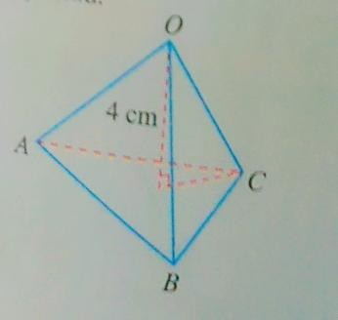

Volume of the triangular pyramid.

**Q3: The number of passengers on coaches travelling along 12 popular scenic routes are /3 29,42,45,39,36,41,38,43,35,32 and 40. Find the mean number of passengers on the coaches.**

**Q4: /4**

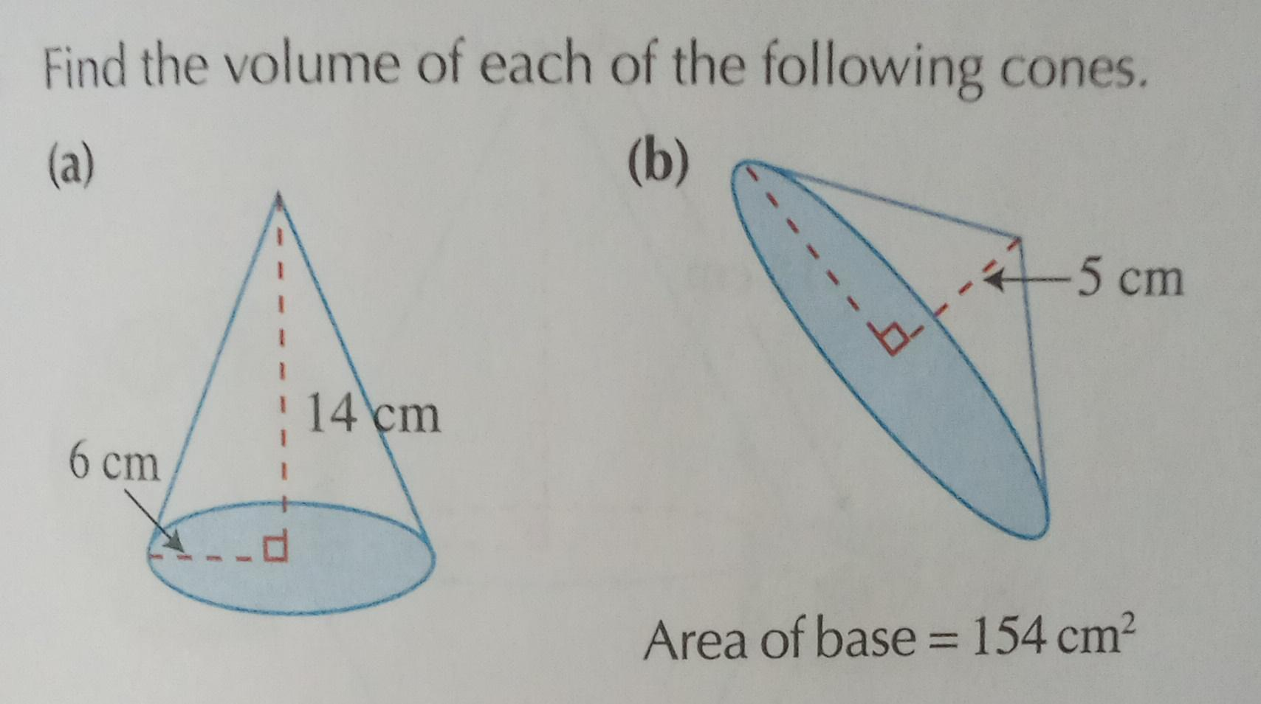

**Q5: Naming the types of Pyramid.** **/1.5**

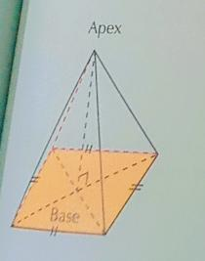 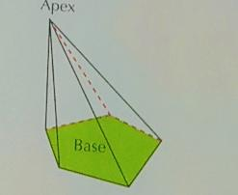 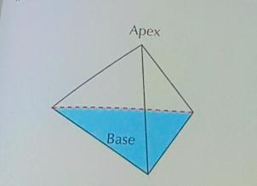

**Q6: The number of goals scored per match by a team during a soccer league season was recorded.**

|  |  |  |  |  |  |  |  |
| --- | --- | --- | --- | --- | --- | --- | --- |
| Number of goals scored per match. | 0 | 1 | 2 | 3 | 4 | 5 | 6 |
| Number of matches. | 6 | 8 | 5 | 6 | 2 | 2 | 1 |

Find **/3.5**

1. The total number of matches played,
2. The total number of goals scored,
3. The mean number of goals scored per match by the team.